Do I need to register for Doctors’ Day on the Hill?
You must register for Day on the Hill via our online event page to ensure sufficient catering and staffing. The last day to register is Friday, February 27, 2026 by 5:00pm CT. Even if you are considering attending but are not sure you can make it, you should go ahead and sign up.
Where is the event?
Doctors’ Day on the Hill takes place in downtown Nashville at the Cordell Hull Building, legislative offices to the Tennessee General Assembly. The address is 425 Rep. John Lewis Way N (formerly 5th Ave. N).
What time do I need to arrive?
Time of arrival will depend on your local medical society and the meetings they set for you. Meetings with legislators will run from 8:30am – 4:00pm CT.
Where should I park?
The closest lot is at the Elizabeth Duff Transit Center connected to the bus station across the street from the Cordell Hull Building (400 Rep. John Lewis Way N). There is a total of 429 spaces, but keep in mind there are monthly parkers so there may be fewer spaces available. The daily Rate: $55

Pro tip: Uber or Lyft is a good option if you are only going for a few hours, or if you ride with someone else down there and leave at a separate time.

Note: TMA will NOT reimburse parking expenses.
What entrance do I use?
The entrance on Rep. John Lewis Way N is the entrance for guests and can accommodate more people than the rear entrance on 6th Ave. Note that the main entrance is located on the ground floor of the Cordell Hull building, while the rear entrance is located on the 2nd floor.

Pro tip: Allow extra time to go through security and don’t forget to bring a driver’s license/photo ID in case there are issues checking in. Avoid wearing lots of metals as it will slow down the security process. Women should travel light and avoid bringing purses, if at all possible, as there will not be a place to store them.

Where do I check in?
If arriving before 10:30am, participants should check in with TMA staff in the café area on floor 1. If arriving after 10:30pm, participants can check in with TMA staff

Where is the student/resident sections meeting?
Medical Students/Residents/Fellows meeting will be held on Floor 8 Conference Room C at 10:15am.

Where are the committee rooms?
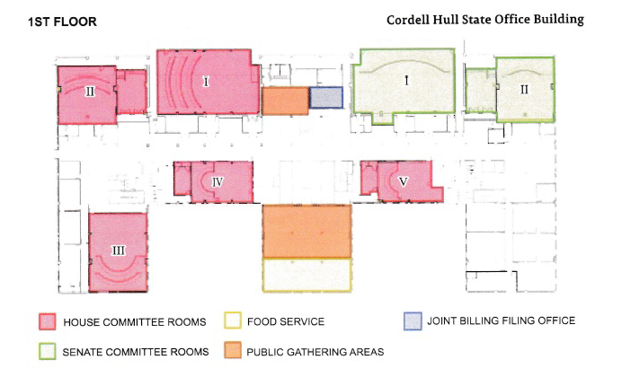
Committee rooms are located on the first floor of the Cordell Hull building. There are a total of five house committee rooms and two senate committee rooms. The committee rooms are indicated on the map below.

What about those who are going to the Capitol? (Residents/Fellows & Medical Students)
Medical Students/Residents/Fellows attendees will meet with TMA designated staff in the middle of conference room 8C and 8D of Cordell Hull. You will be escorted to the Capitol.
Pro tip: We will be taking a photo of all residents/fellows and medical students on the stairs outside the Capitol.
What floors are member offices?
Floors 4, 5, and 6 are House member offices. Floor 7 is Senate offices.
Pro tip: Elevators are imperative to access member offices; however, consider taking the stairs if you only need to move up or down a floor. As more people enter the Cordell Hull Building, the elevators become congested and are less efficient.
Where are the restrooms?
Restrooms flank both “wings” of the Cordell Hull building on every floor. There are two ADA-approved restrooms on each floor.

Where are we having lunch?
Boxed lunches will be provided on the 8th floor in conference rooms 8C-8D. A map of the 8th floor is below.
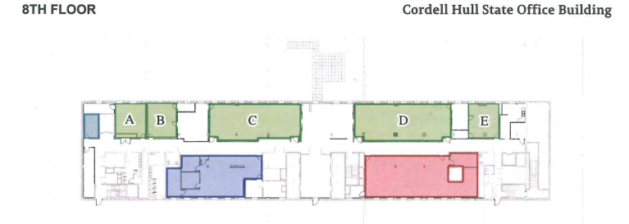
What other rooms should I be aware of?
- Nurse’s suite –ground floor
- Mothers’ nursing rooms – ground floor and floor 6
- Grab-n-go/Cafeteria – located on floor 1; closes at 2 pm

